DiceWitch Workshop Examples: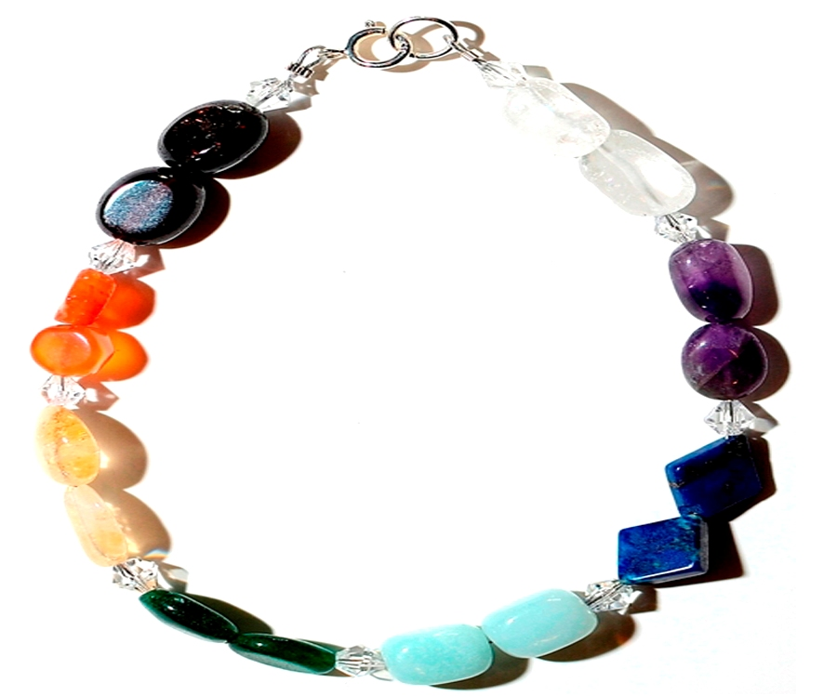
Chakra Beading and Meditation

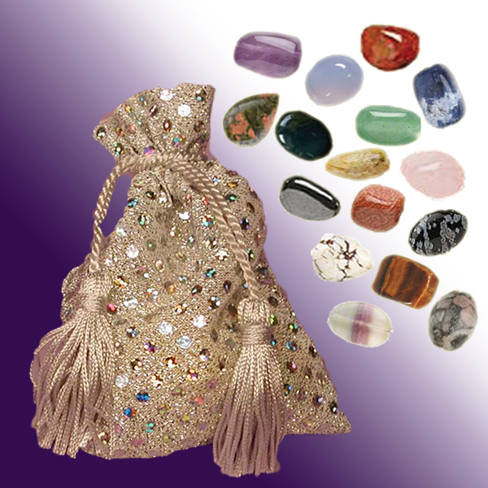
Fortune Telling Stones
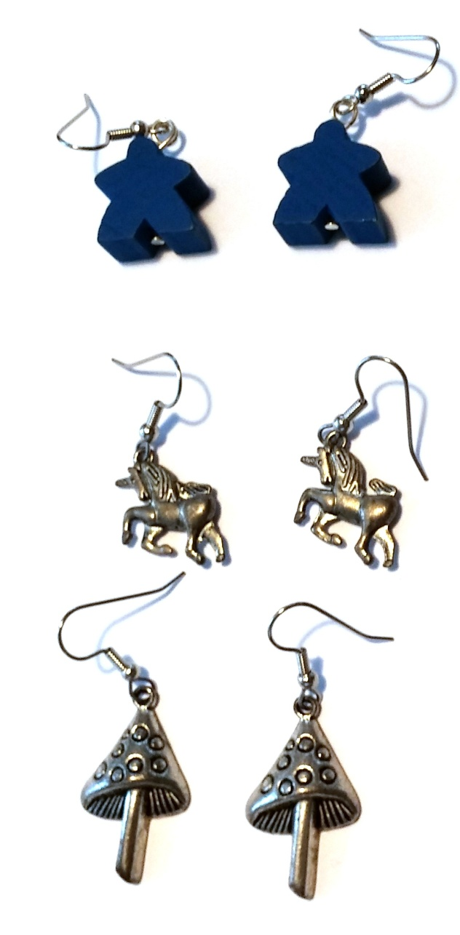
Meeple and Fantasy Earrings
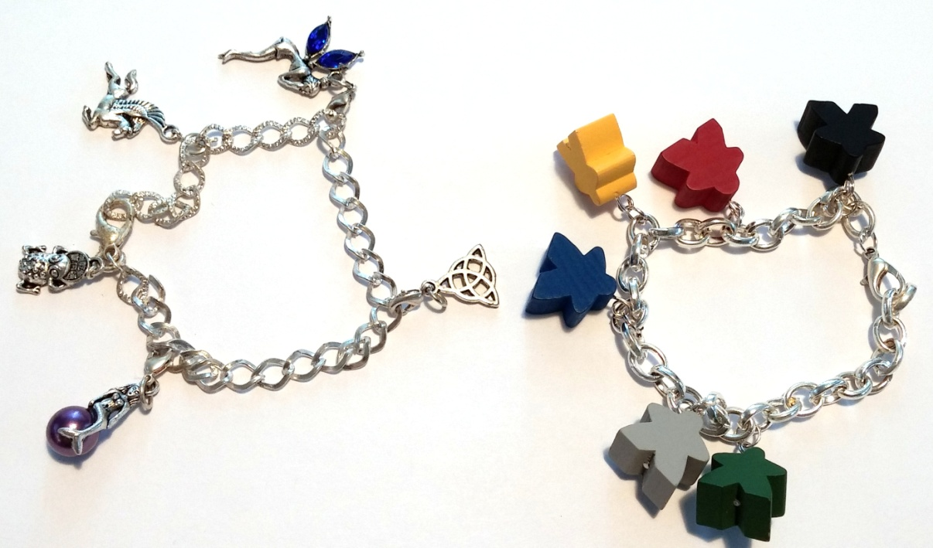
Meeple and Fantasy Charm Bracelets

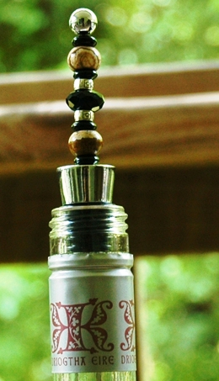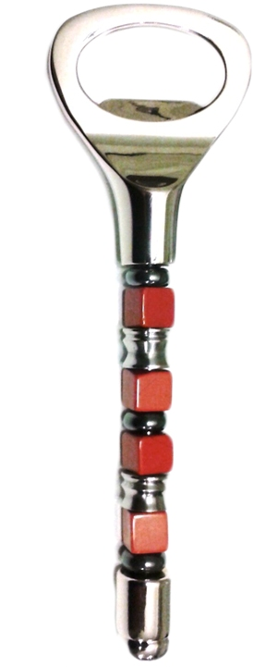

Bottle Stopper (Pandora Style) Bottle Opener (Pandora Style)

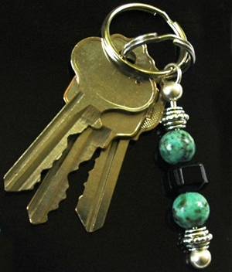
Keychain (Pandora Style)

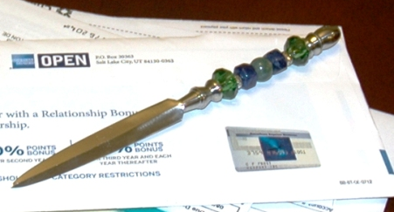
Letter Opener/Athame (Pandora Style)

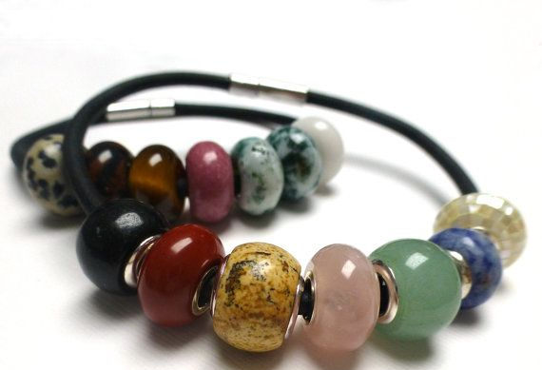
Bracelet (Pandora Style)

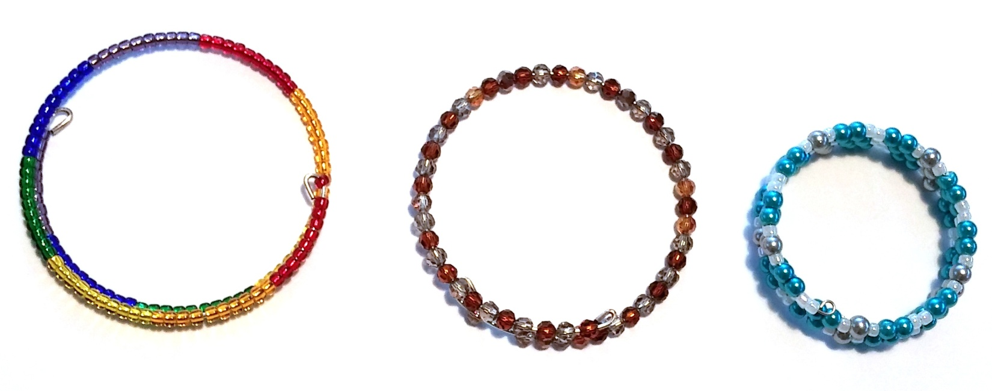
Beaded Napkin Rings

